**LAPORAN PRAKTIKUM**

**WEB PROGRAMMING & TESTING**

**Audyva Irefilevitasari Alifia**

Quality Engineer-A, Alterra

Email: audyvairefilevitasarialifia9@gmail.com

**Universitas Brawijaya**

**Soal Web Programming**

1. **Soal Prioritas 1**
2. Buatlah sebuah halaman web dengan tampilan seperti berikut:

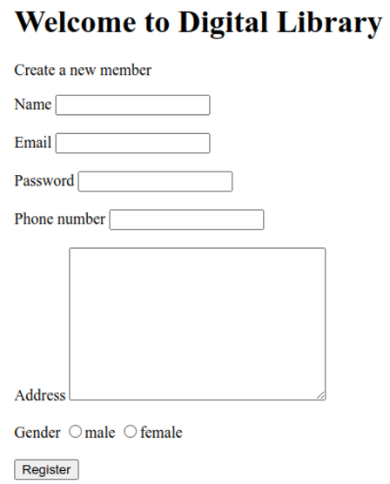

Jawab:

1. Source Code

| Prak11.1.html | |
| --- | --- |
| 1  2  3  4  5  6  7  8  9  10  11  12  13  14  15  16  17  18  19  20  21  22  23  24  25  26  27  28  29  30  31  32  33  34  35  36  37  38  39  40  41  42  43  44  45  46  47  48  49  50  51  52  53  54  55  56  57  58  59  60  61  62  63  64  65  66  67  68  69 | <!DOCTYPE html>  <html>  <head>  <title>Digital Library - Register</title>  <style>  form div {  margin-bottom: 10px;  display: flex;  flex-direction: row;  align-items: center;  }  label {  width: 120px;  text-align: left;  margin-right: 10px;  }  input[type="radio"] {  margin-right: 5px;  }  </style>  </head>  <body>  <header>  <h1>Welcome to Digital Library</h1>  </header>  <main>  <p>Create a new member</p>  <form>  <div>  <label for="name">Name:</label>  <input type="text" id="name" name="name" required>  </div>  <div>  <label for="email">Email:</label>  <input type="email" id="email" name="email" required>  </div>  <div>  <label for="password">Password:</label>  <input type="password" id="password" name="password" required>  </div>  <div>  <label for="phone">Phone number:</label>  <input type="tel" id="phone" name="phone" required>  </div>  <div>  <label for="address">Address:</label>  <textarea id="address" name="address" rows="5"></textarea>  </div>  <div>  <label for="gender">Gender:</label>  <label for="male">  <input type="radio" id="male" name="gender" value="male" required> Male  </label>  <label for="female">  <input type="radio" id="female" name="gender" value="female" required> Female  </label>  </div>  <button type="submit">Register</button>  </form>  </main>  </body>  </html> |

1. Screenshots
2. Tampilan code main

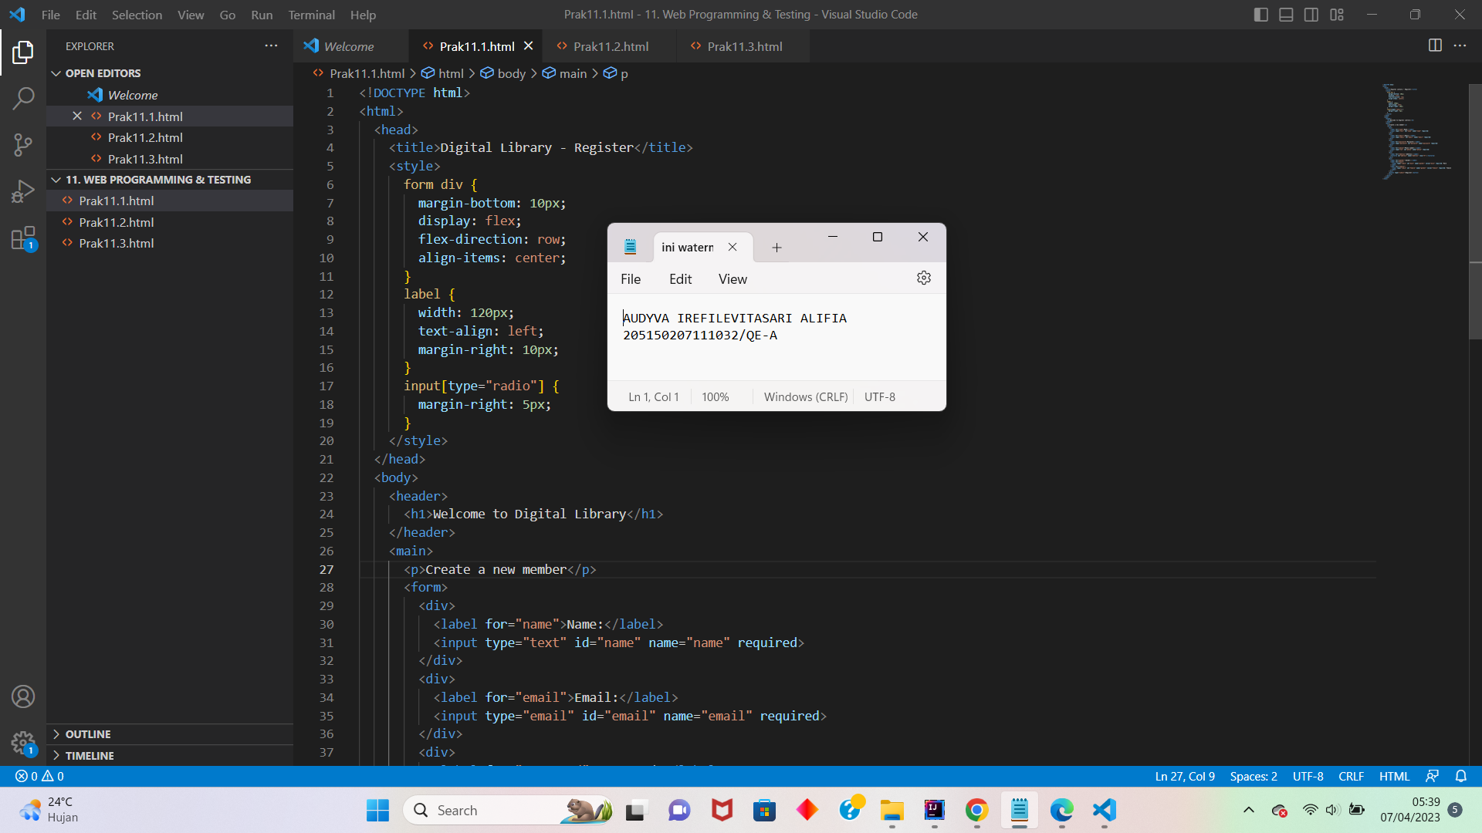

1. Hasil Output

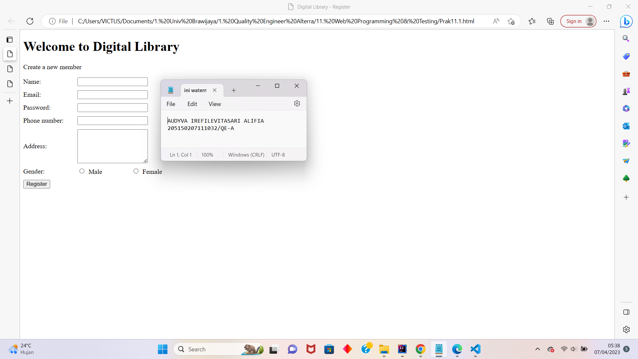

1. Sfs
2. **Soal Prioritas 2**
3. Buatlah sebuah halaman web dengan tampilan seperti berikut:

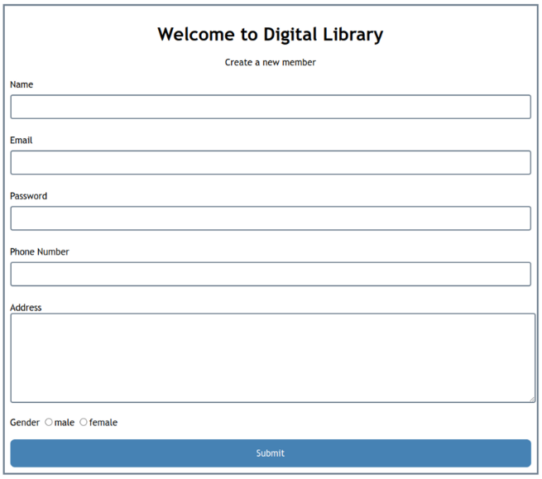

Jawab:

1. Source Code

| Prak11.2.html | |
| --- | --- |
| 1  2  3  4  5  6  7  8  9  10  11  12  13  14  15  16  17  18  19  20  21  22  23  24  25  26  27  28  29  30  31  32  33  34  35  36  37  38  39  40  41  42  43  44  45  46  47  48  49  50  51  52  53  54  55  56  57  58  59  60  61  62  63  64  65  66  67  68  69  70  71  72  73  74  75  76  77  78  79  80  81  82  83  84  85  86  87  88  89  90  91  92  93  94  95  96  97  98  99  100  101  102  103  104  105  106  107  108  109  110  111  112  113  114 | <!DOCTYPE html>  <html>  <head>  <title>Digital Library - Register</title>  <style>  body {  margin: 0;  padding: 0;  box-sizing: border-box;  }  .container {  max-width: 95%;  margin: 20px auto;  border: 1px solid black;  padding: 20px;  }  header {  background-color: #4CAF50;  color: white;  text-align: center;  padding: 15px;  }  form div {  margin-bottom: 10px;  }  label {  display: block;  margin-bottom: 5px;  }  input[type="radio"] {  margin-right: 5px;  }  input[type="text"],  input[type="email"],  input[type="password"],  input[type="tel"],  textarea {  width: 100%;  padding: 10px;  border: 1px solid #ccc;  border-radius: 4px;  box-sizing: border-box;  resize: vertical;  }  button[type="submit"] {  display: block;  width: 100%;  padding: 10px;  background-color: #4CAF50;  color: white;  border: none;  border-radius: 4px;  cursor: pointer;  }  .gender {  display: inline-block;  margin-right: 10px;  }  </style>  </head>  <body>  <div class="container">  <header>  <h1>Welcome to Digital Library</h1>  </header>  <main>  <h2>Create a new member</h2>  <form>  <div>  <label for="name">Name:</label>  <input type="text" id="name" name="name" required>  </div>  <div>  <label for="email">Email:</label>  <input type="email" id="email" name="email" required>  </div>  <div>  <label for="password">Password:</label>  <input type="password" id="password" name="password" required>  </div>  <div>  <label for="phone">Phone number:</label>  <input type="tel" id="phone" name="phone" required>  </div>  <div>  <label for="address">Address:</label>  <textarea id="address" name="address" rows="5"></textarea>  </div>  <div>  <label>Gender:</label>  <div class="gender">  <label for="male">  <input type="radio" id="male" name="gender" value="male" required> Male  </label>  </div>  <div class="gender">  <label for="female">  <input type="radio" id="female" name="gender" value="female" required> Female  </label>  </div>  </div>  <button type="submit">Submit</button>  </form>  </main>  </div>  </body>  </html> |

1. Screenshots
2. Tampilan code main

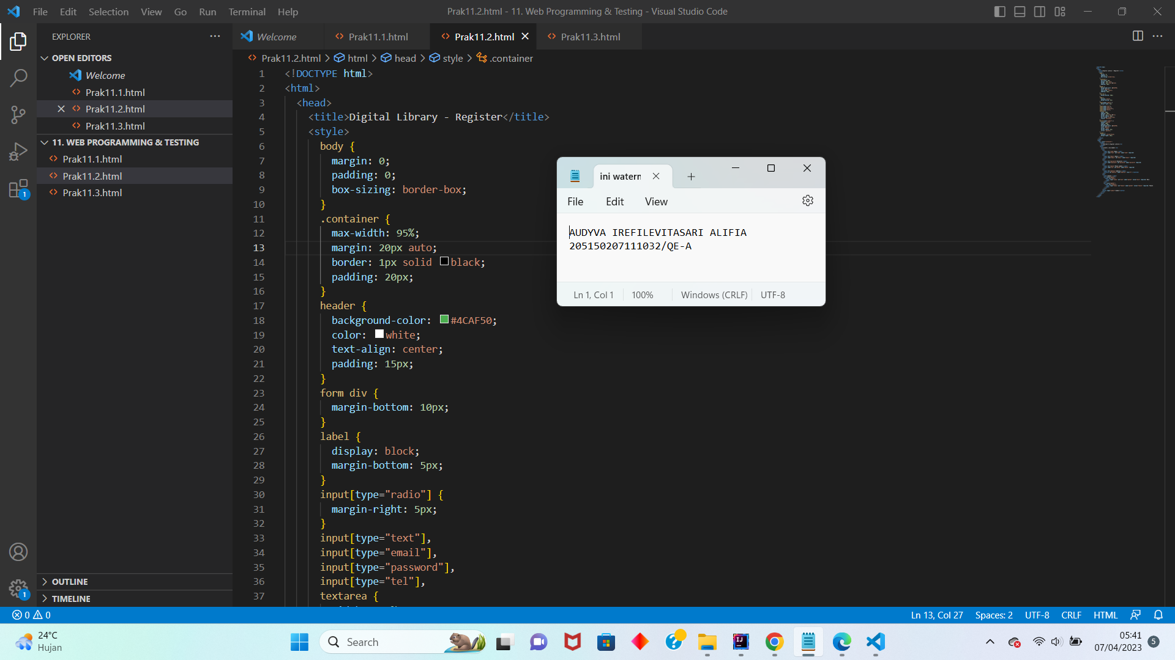

1. Hasil output

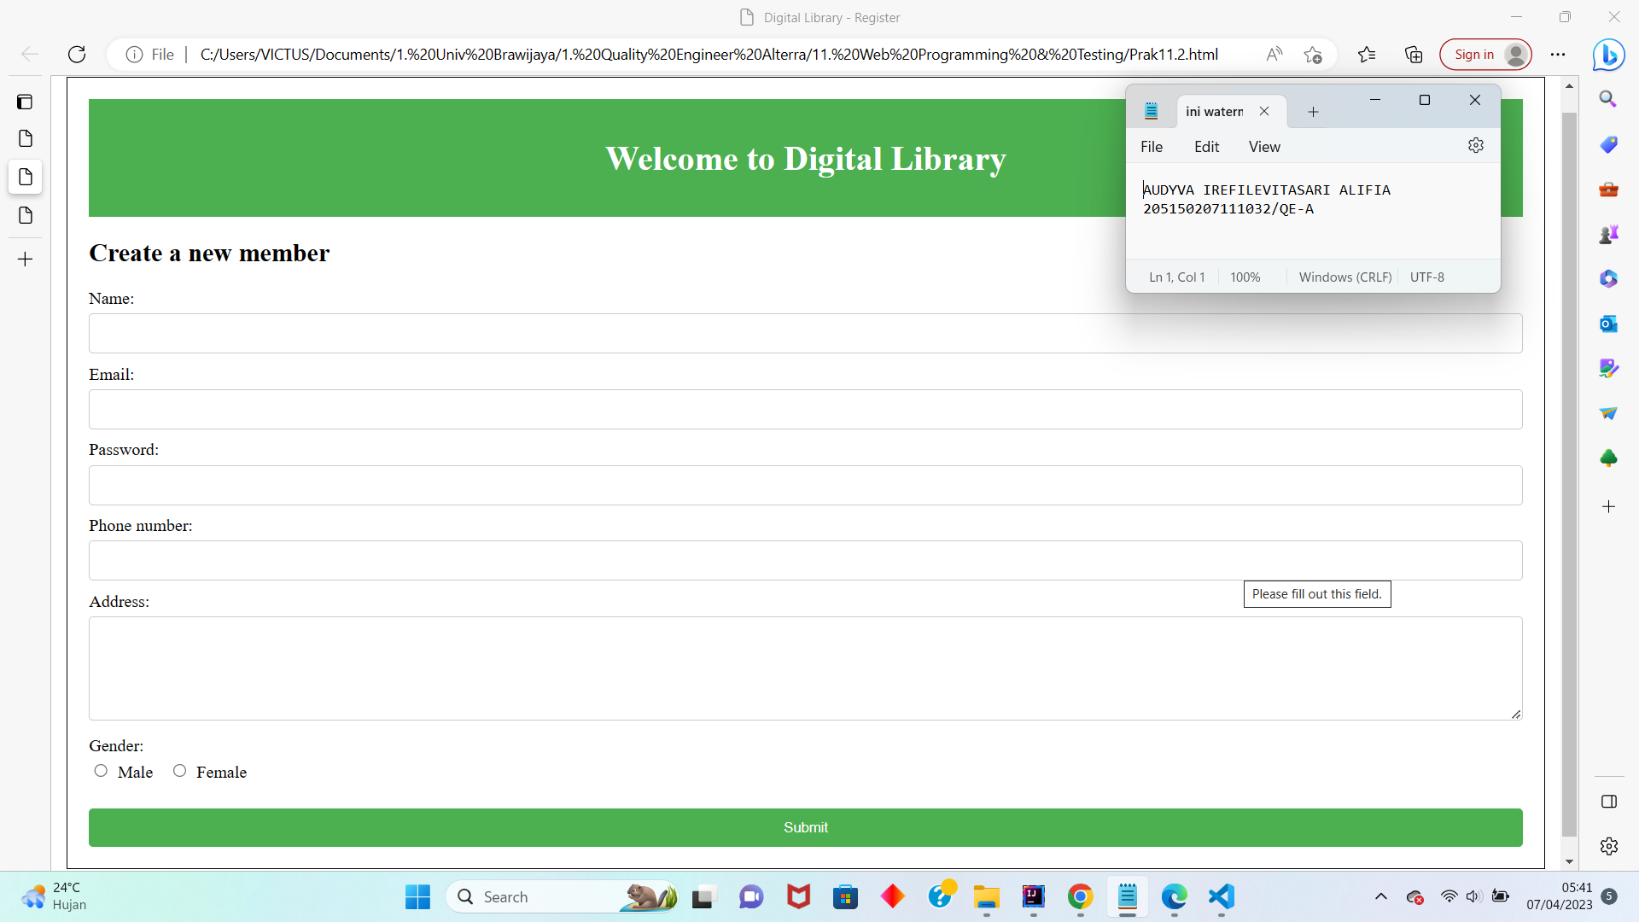

1. L
2. D
3. D
4. **Soal Eksplorasi**
5. Buatlah sebuah halaman website dengan tampilan seperti berikut.

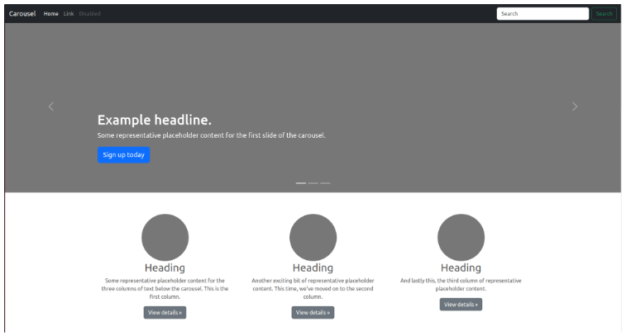

Jawab:

1. Source code

| Prak11.3.html | |
| --- | --- |
| 1  2  3 |  |

1. Screenshots

**Soal Web UI Testing**

1. **Soal Prioritas 1**
2. Buatlah 3 test case pada halaman web<https://www.saucedemo.com/> dengan kriteria sebagai berikut:
3. Terdapat case positif dan negatif.
4. Pengujian menggunakan Serenity.

Jawab:

1. Link file zip: <https://drive.google.com/file/d/1IrFHM7_vIrhiwMZLN_Iq8Se-zAefpzPm/view?usp=share_link>
2. Link Folder: <https://drive.google.com/drive/folders/1Is2XKnxslTVYluhkQo1-dQWRtqzQeqBT?usp=share_link>
3. Results:
4. Terminal:

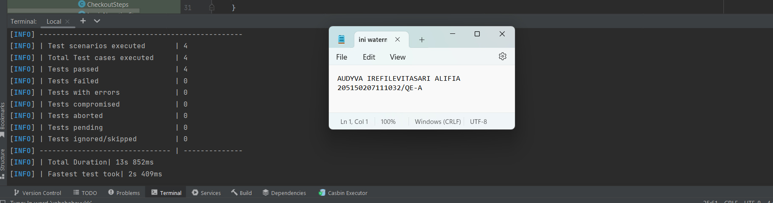

1. Full Report Serenity: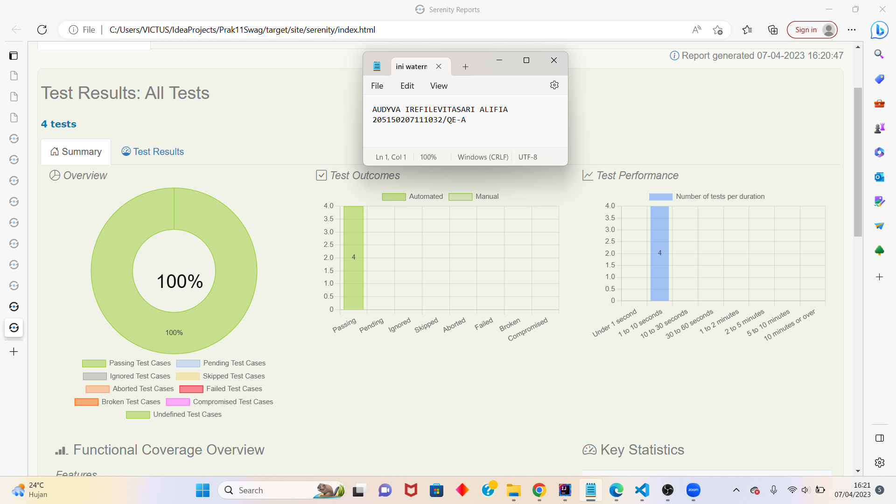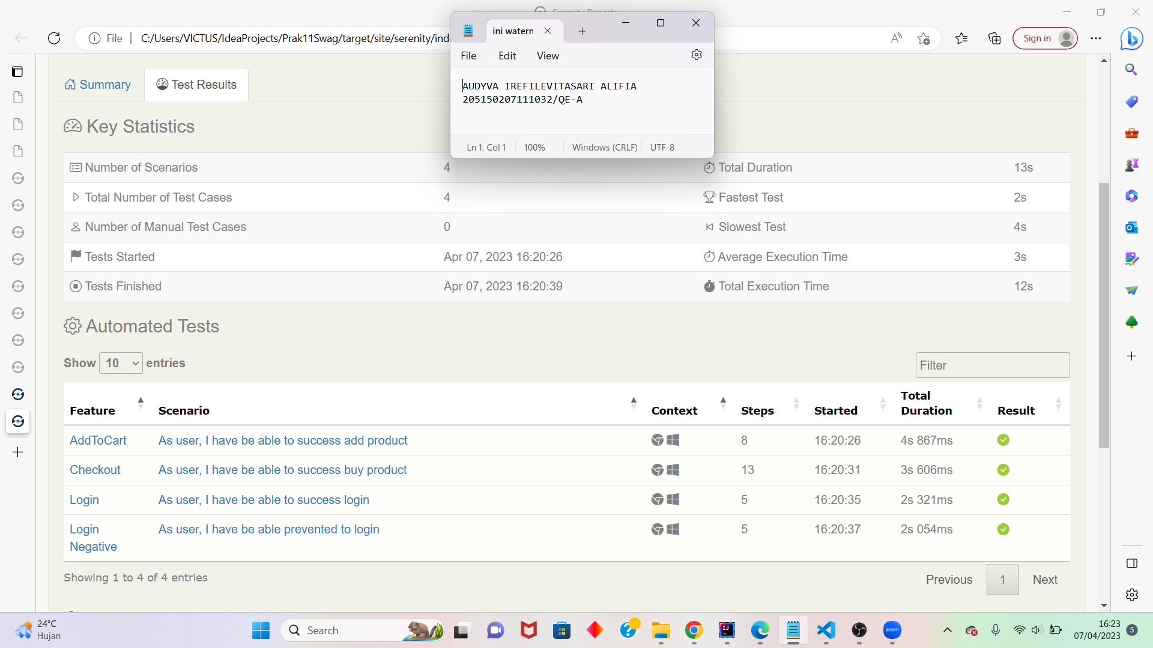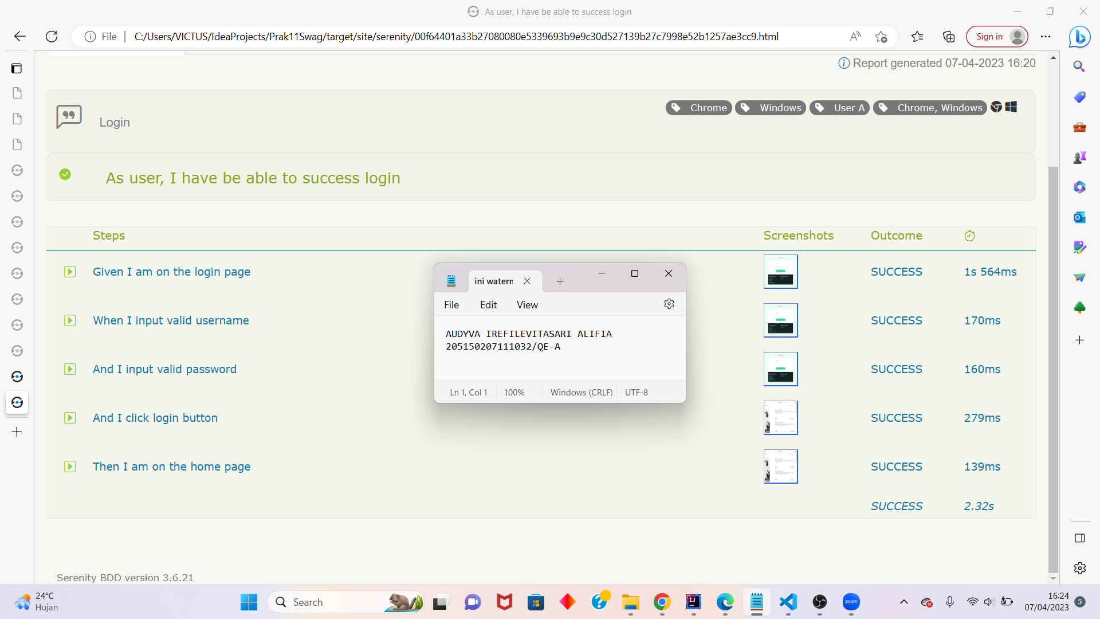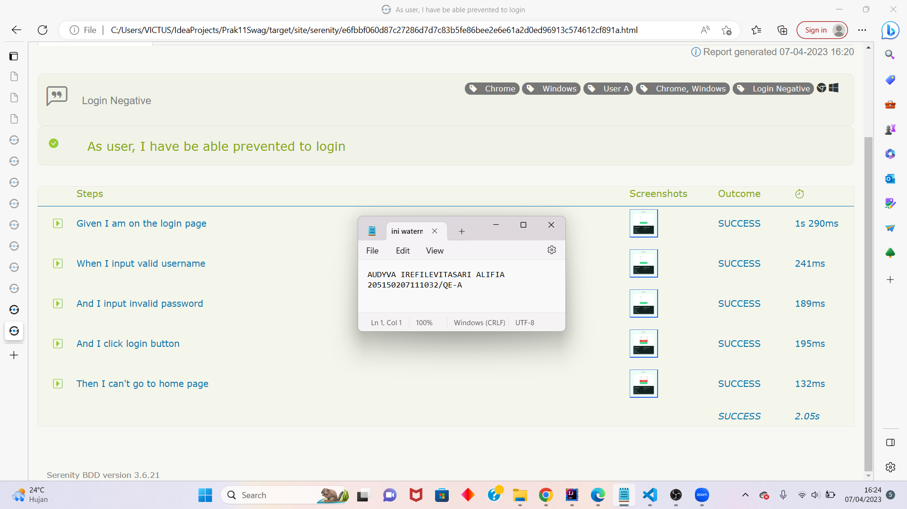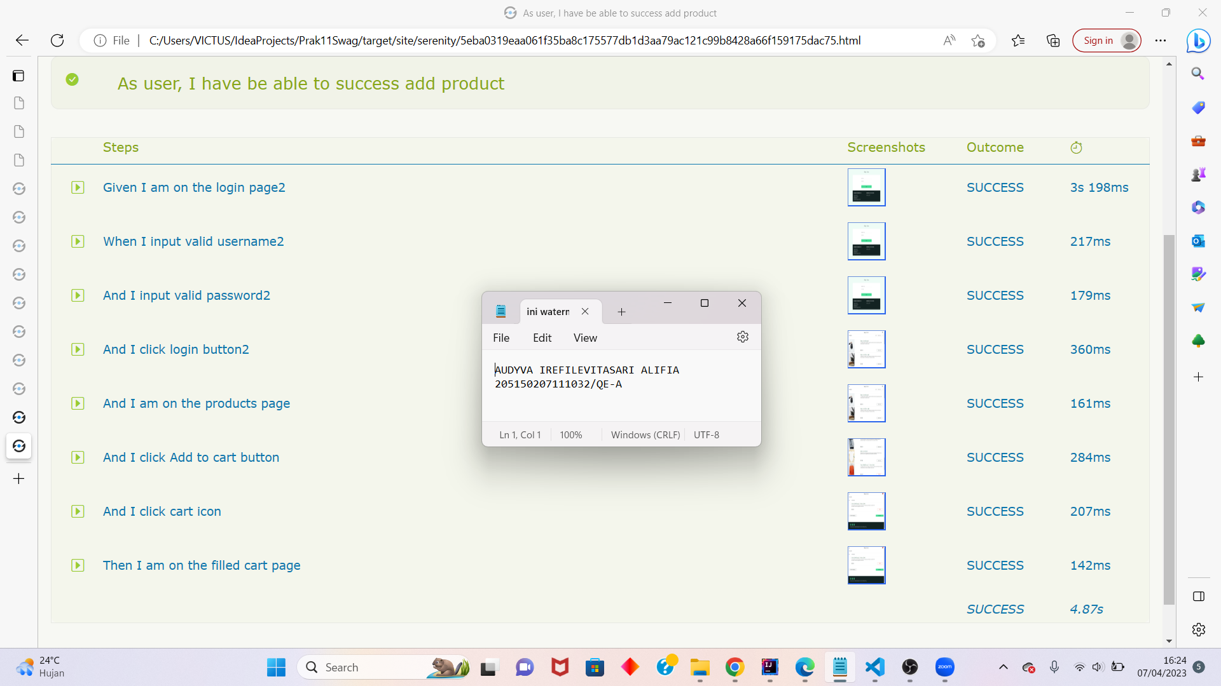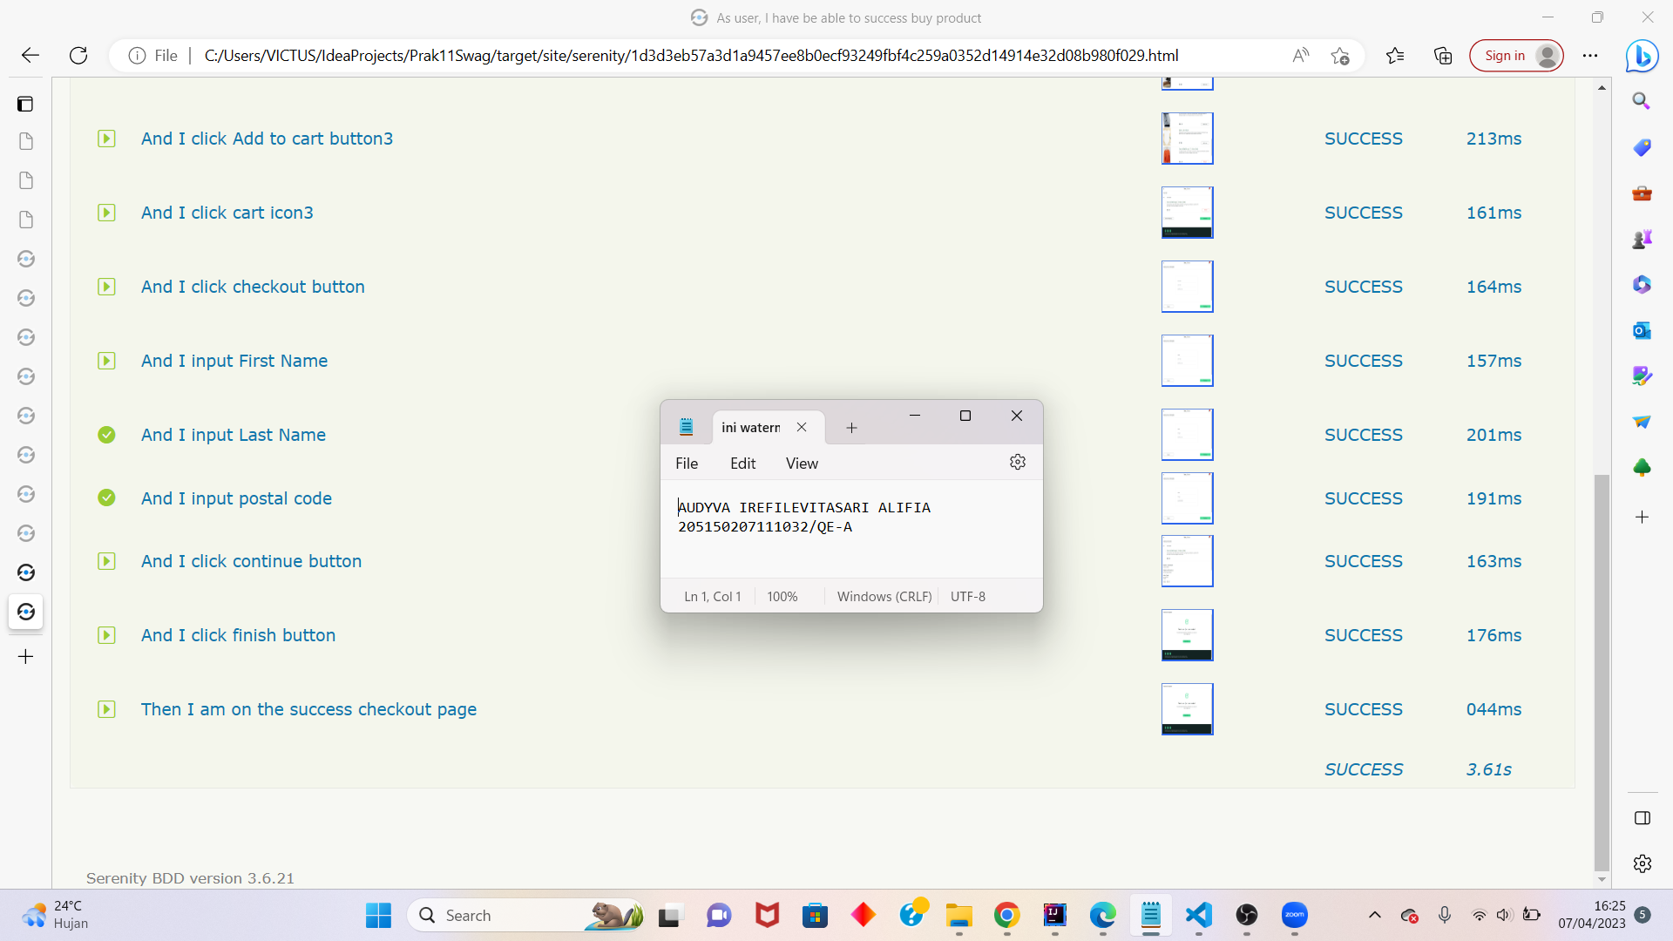
2. **Soal Prioritas 2**
3. Buatlah 3 test case pada halaman web<https://www.sepulsa.com/> dengan kriteria sebagai berikut:
4. Fitur yang dilakukan testing adalah login, pilih produk dan pilih metode pembayaran.
5. Terdapat case positif dan negatif.
6. Pengujian menggunakan Serenity.

Jawab:

1. Link file zip: <https://drive.google.com/file/d/16nRYnZaJ44A1gpNQ1A09UkTBFMV1T7JA/view?usp=share_link>
2. Link Folder: <https://drive.google.com/drive/folders/16pEBXeZ3kTGEUDOi_Fde7tjeBUDff4Ao?usp=share_link>
3. Results:
4. Terminal:

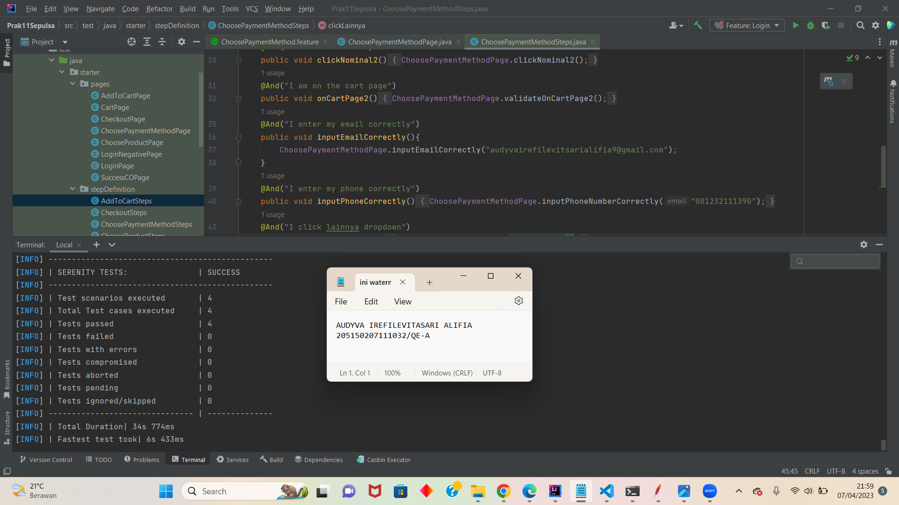

1. Full Report Serenity:

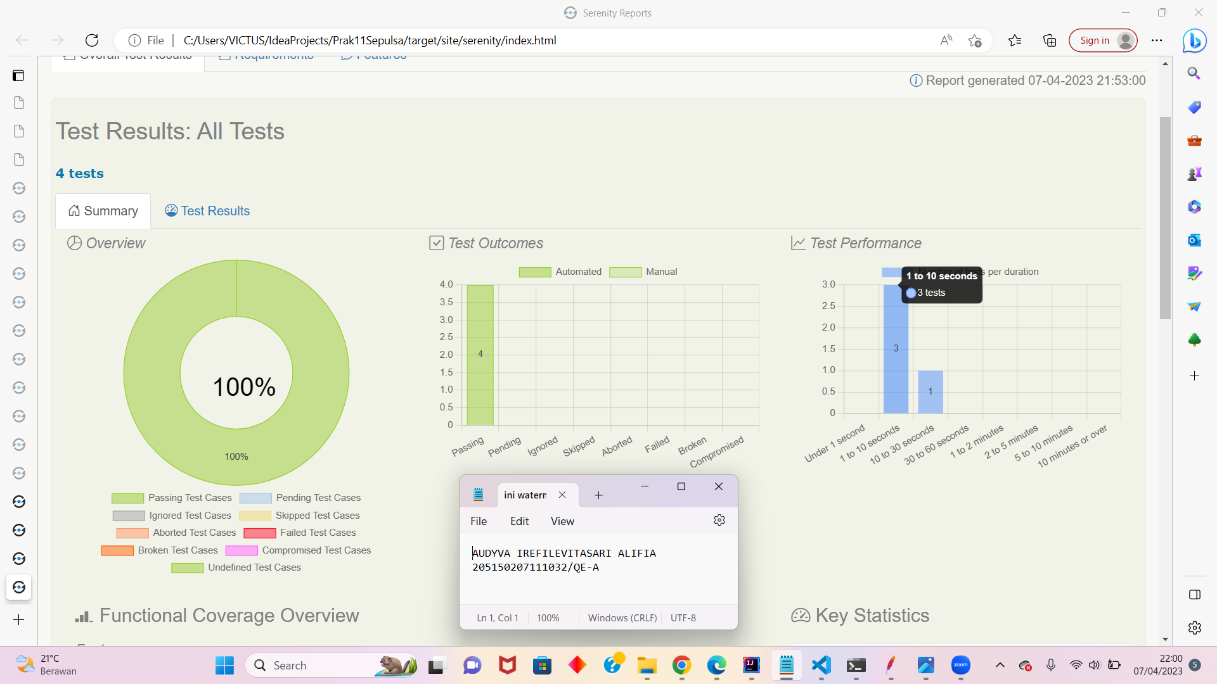

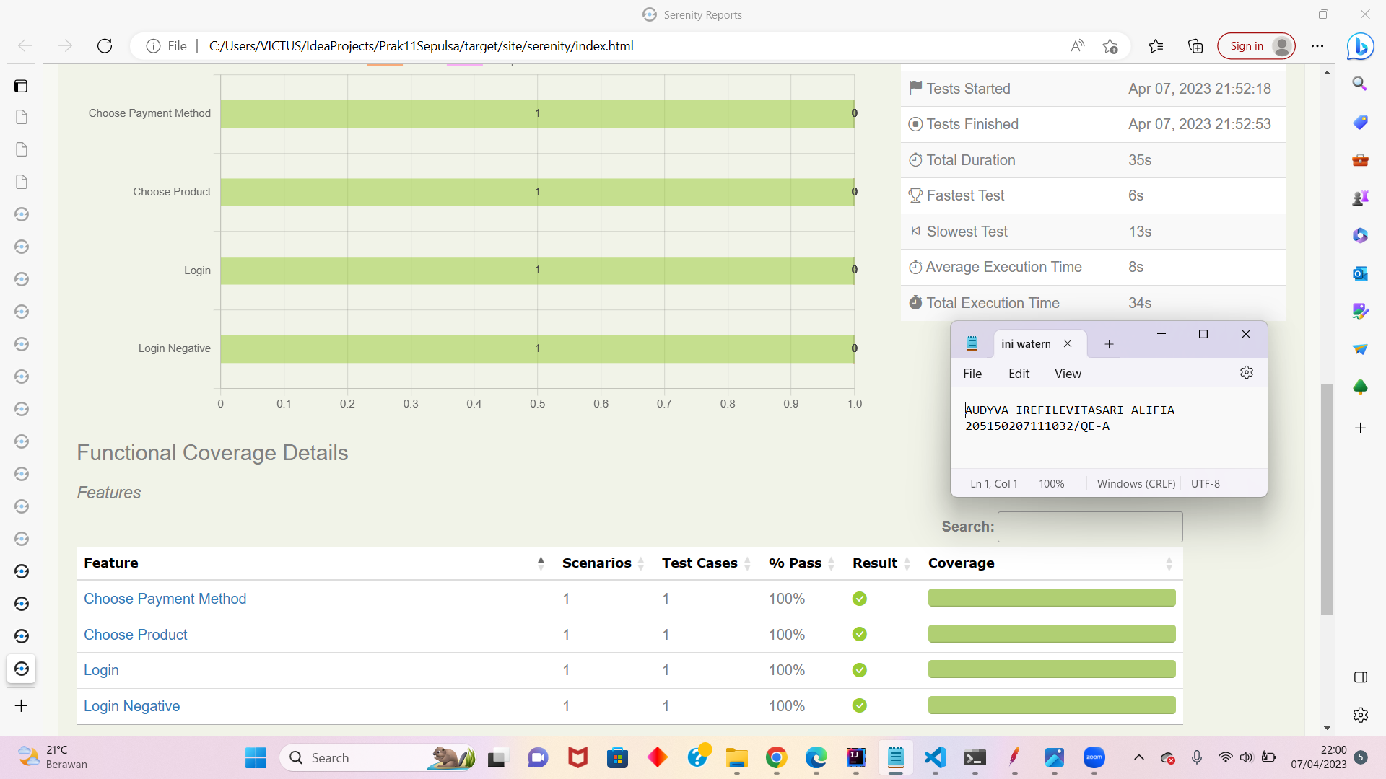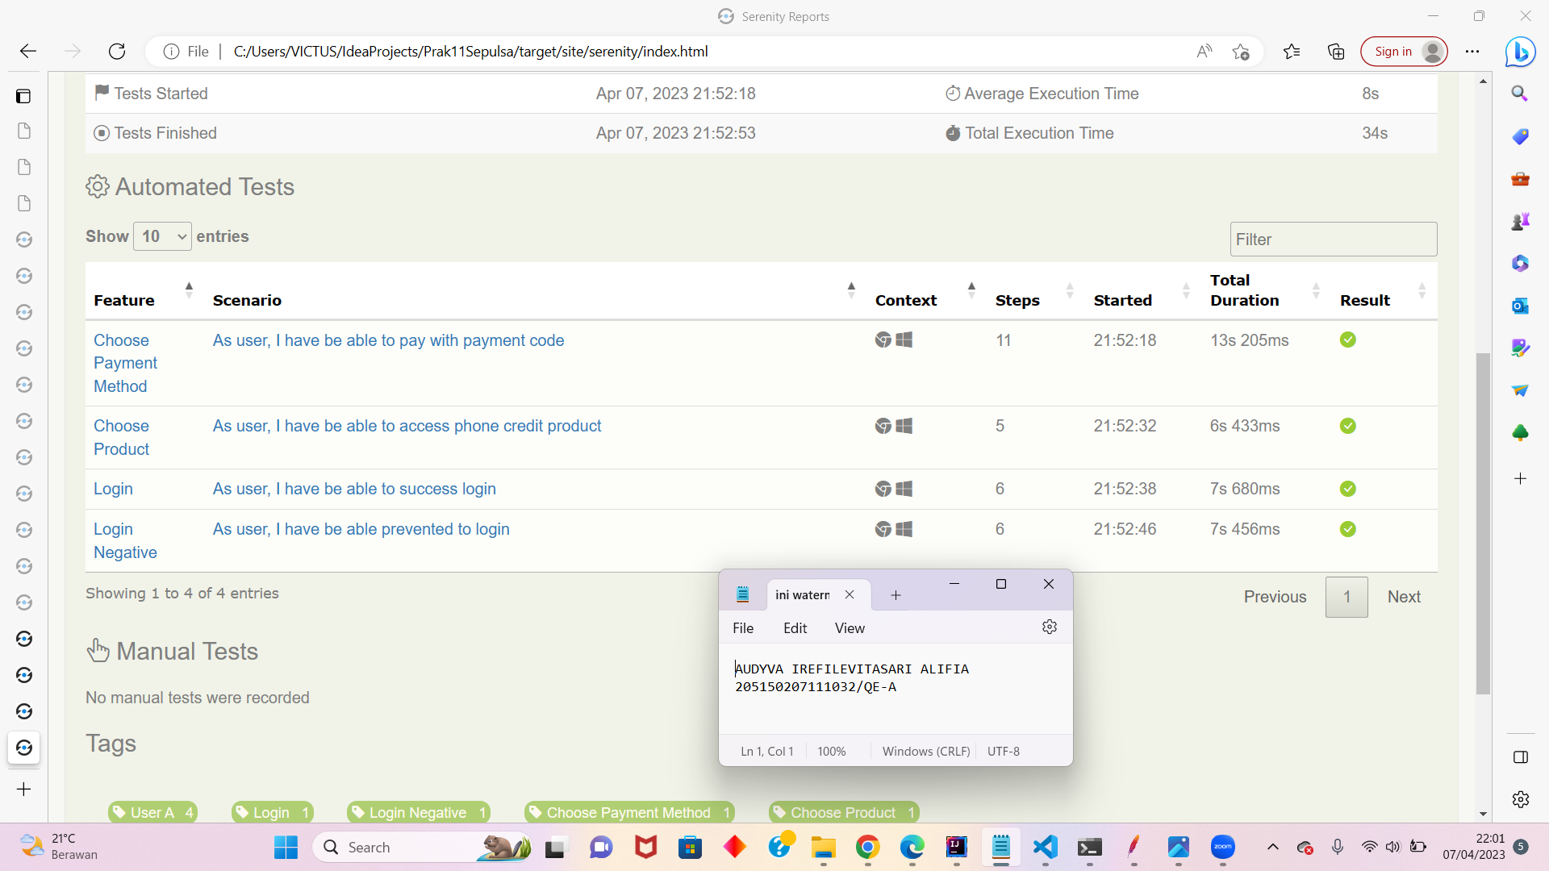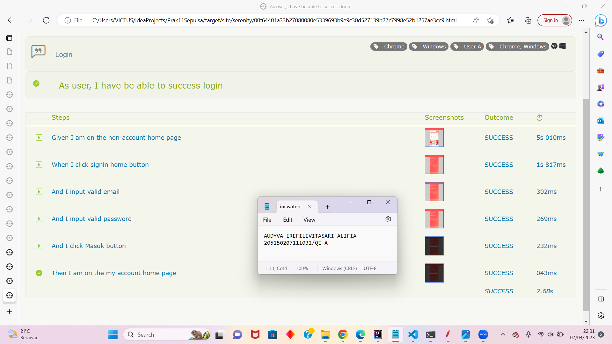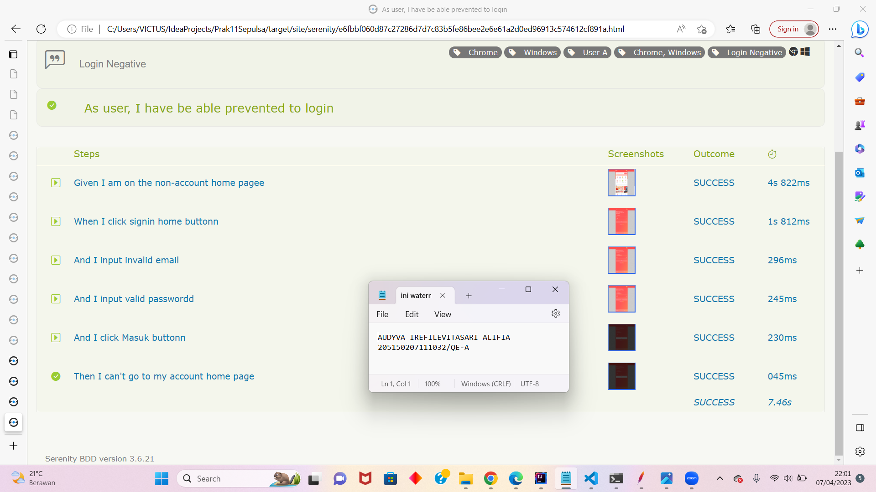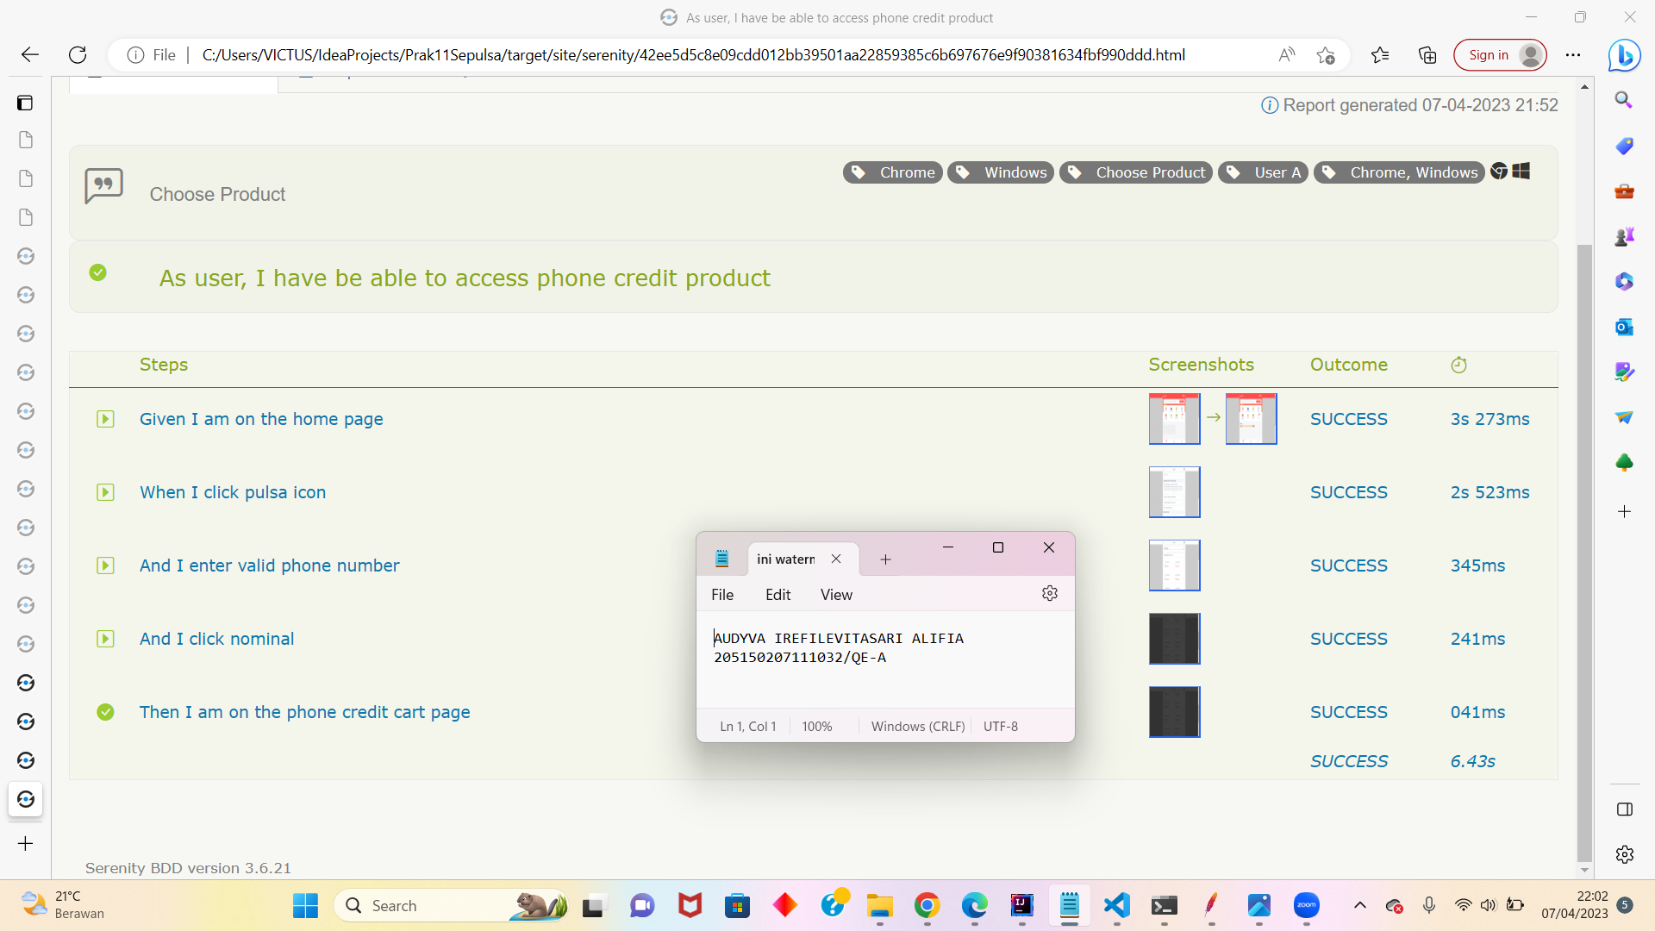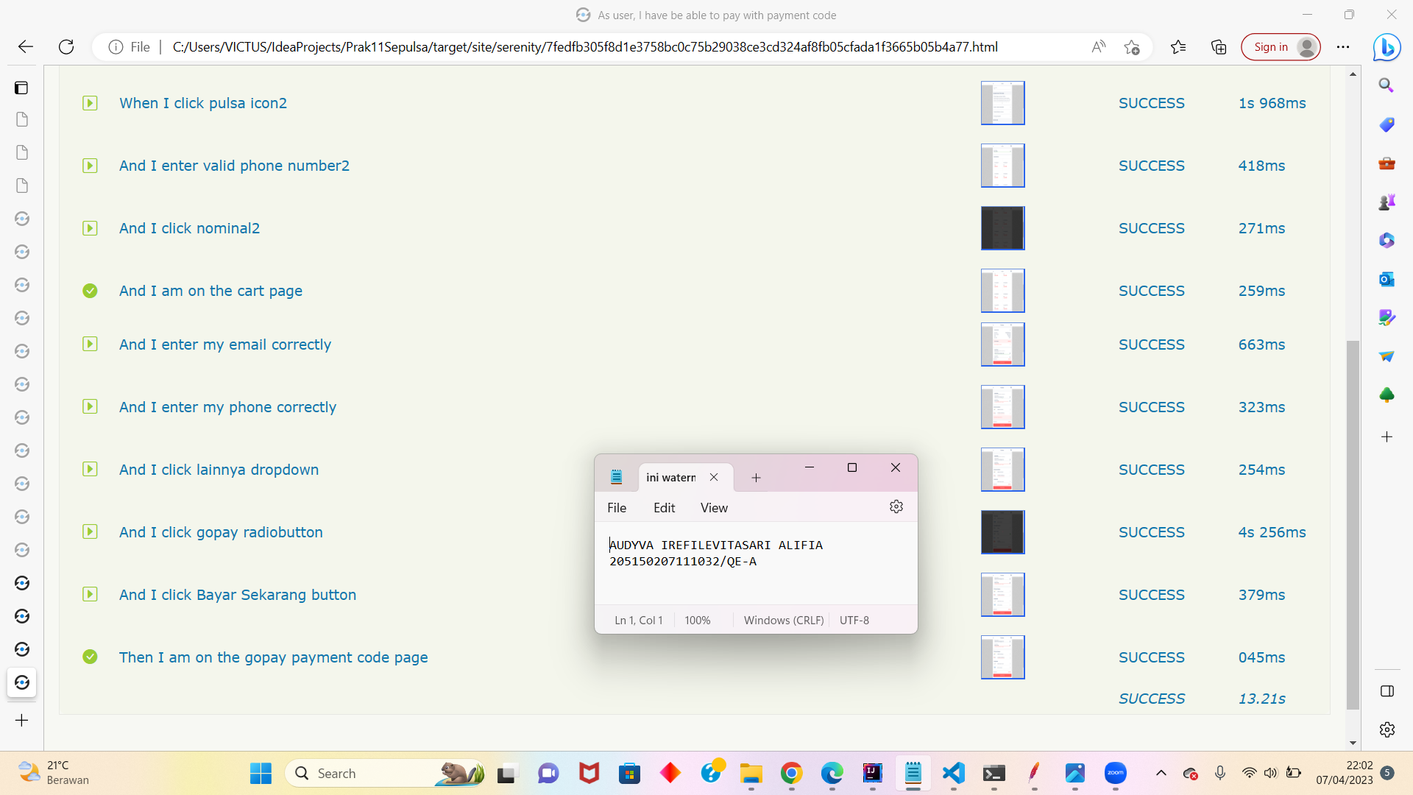

1. **Soal Eksplorasi**
2. Buatlah 3 test case pada halaman web<https://www.sepulsa.com/> dengan kriteria sebagai berikut:
3. Fitur yang dilakukan testing adalah login, pilih produk dan pilih metode pembayaran.
4. Terdapat case positif dan negatif.
5. Pengujian menggunakan **Selenium**. Selenium dapat menggunakan [extension](https://chrome.google.com/webstore/detail/selenium-ide/mooikfkahbdckldjjndioackbalphokd?hl=en) untuk Google Chrome.

Jawab:

1. Link file zip:
2. Link Folder:
3. Results:
4. Terminal:
5. Full Report Serenity: